1.Create an IAM User and Assign EC2 & S3 Full Access
Step 1: Log in to the AWS Management Console.
Step 2: In the search bar, type IAM and open the IAM service.
Step 3: In the left navigation pane, click Users.
Step 4: Click Create user.
Step 5: Enter a username (for example, EC2S3User).
Step 6: Click Next.
Step 7: Select Attach policies directly.
Step 8: Search for and select AmazonEC2FullAccess.
Step 9: Search for and select AmazonS3FullAccess.
Step 10: Click Next.
Step 11: Review the user details and attached policies.
Step 12: Click Create user.
Step 13: Open the newly created user and go to the Permissions tab.
Step 14: Verify that AmazonEC2FullAccess and AmazonS3FullAccess are attached.
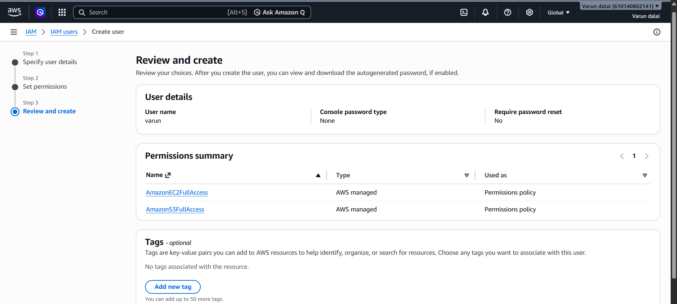

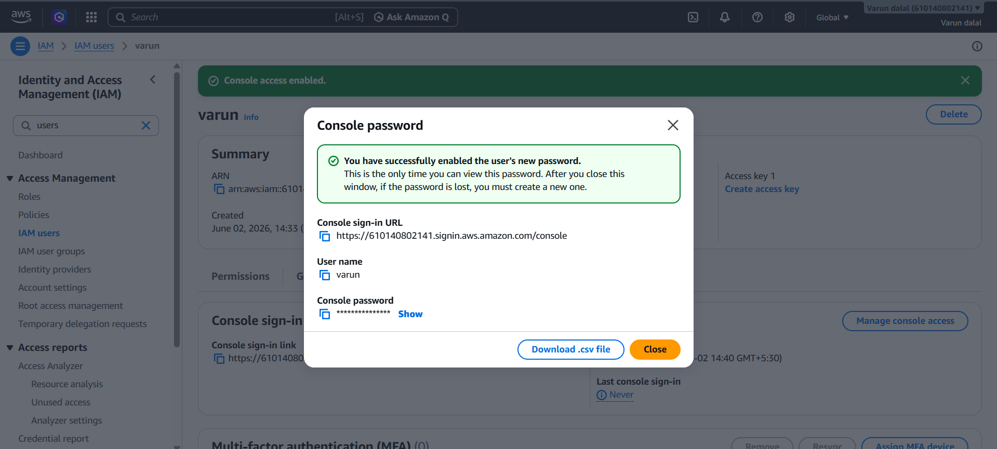
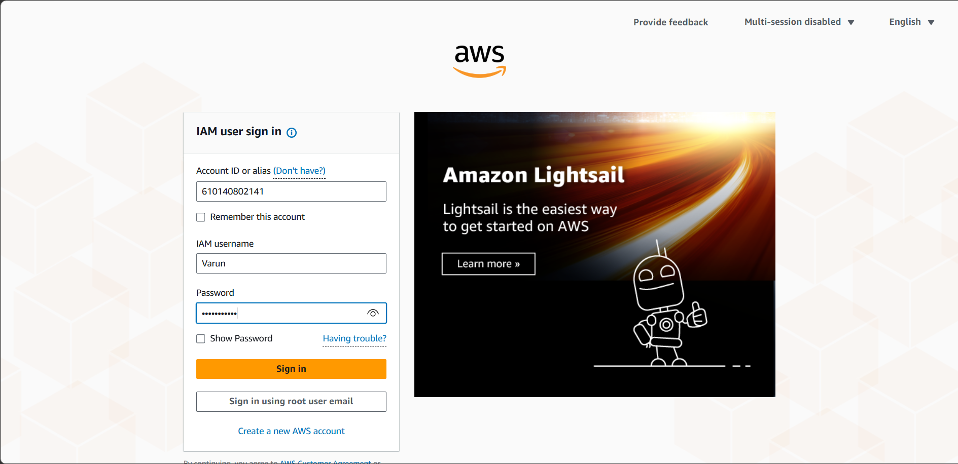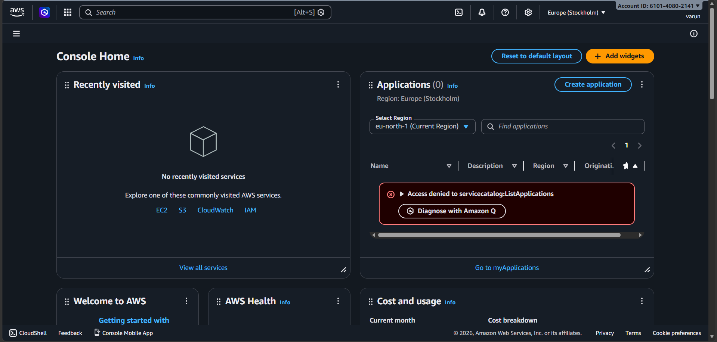

Validation
- Navigate to IAM → Users → EC2S3User → Permissions.
- Confirm that the following policies are listed:
  - AmazonEC2FullAccess
  - AmazonS3FullAccess

2. Create one group in IAM and assign read access for EC2
Step 1: Log in to the AWS Management Console.
Step 2: Open the IAM service.
Step 3: In the left navigation pane, click User groups.
Step 4: Click Create group.
Step 5: Enter a group name (for example, EC2ReadOnlyGroup).
Step 6: Under Attach permissions policies, search for AmazonEC2ReadOnlyAccess.
Step 7: Select AmazonEC2ReadOnlyAccess.
Step 8: Click Create group.
Step 9: Open the newly created group.
Step 10: Click Add users.
Step 11: Select the IAM user(s) you want to add.
Step 12: Click Add users.
Validation
Step 13: Go to IAM → User groups → EC2ReadOnlyGroup → Permissions.
Step 14: Verify that the AmazonEC2ReadOnlyAccess policy is attached

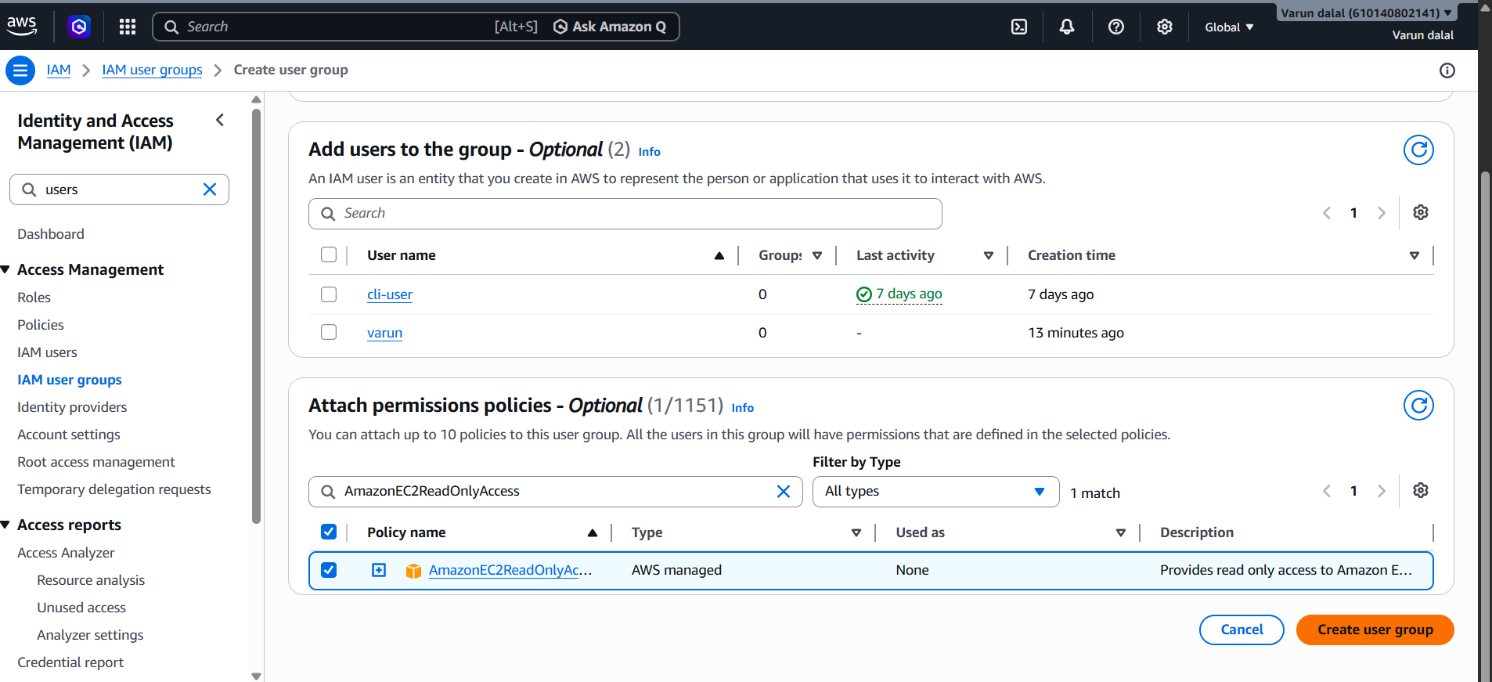

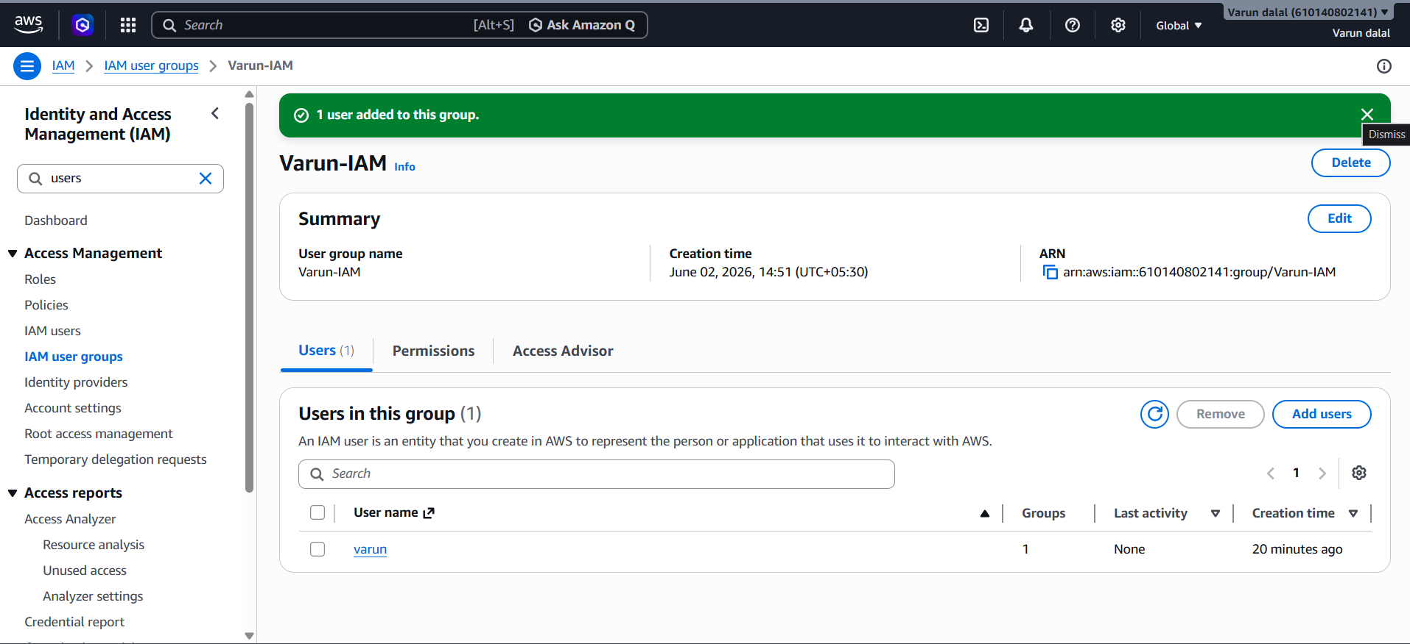

3.Create a new user named "Devops" and add to the group created in task 2
Step 1: Log in to the AWS Management Console.
Step 2: Open the IAM service.
Step 3: In the left navigation pane, click Users.
Step 4: Click Create user.
Step 5: Enter the username Devops.
Step 6: Click Next.
Step 7: Select Add user to group.
Step 8: Choose the group created in Task 2 (e.g., EC2ReadOnlyGroup).
Step 9: Click Next.
Step 10: Review the user details and selected group.
Step 11: Click Create user.
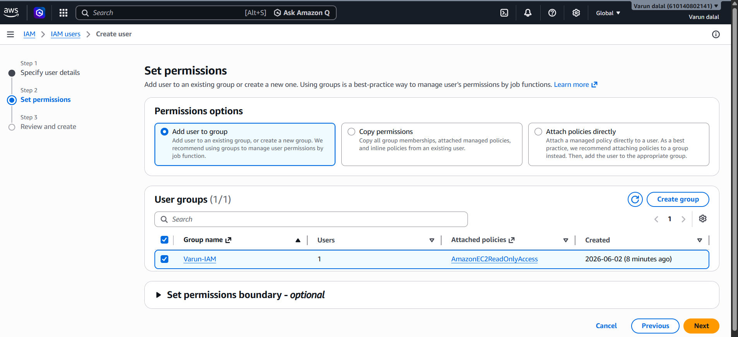
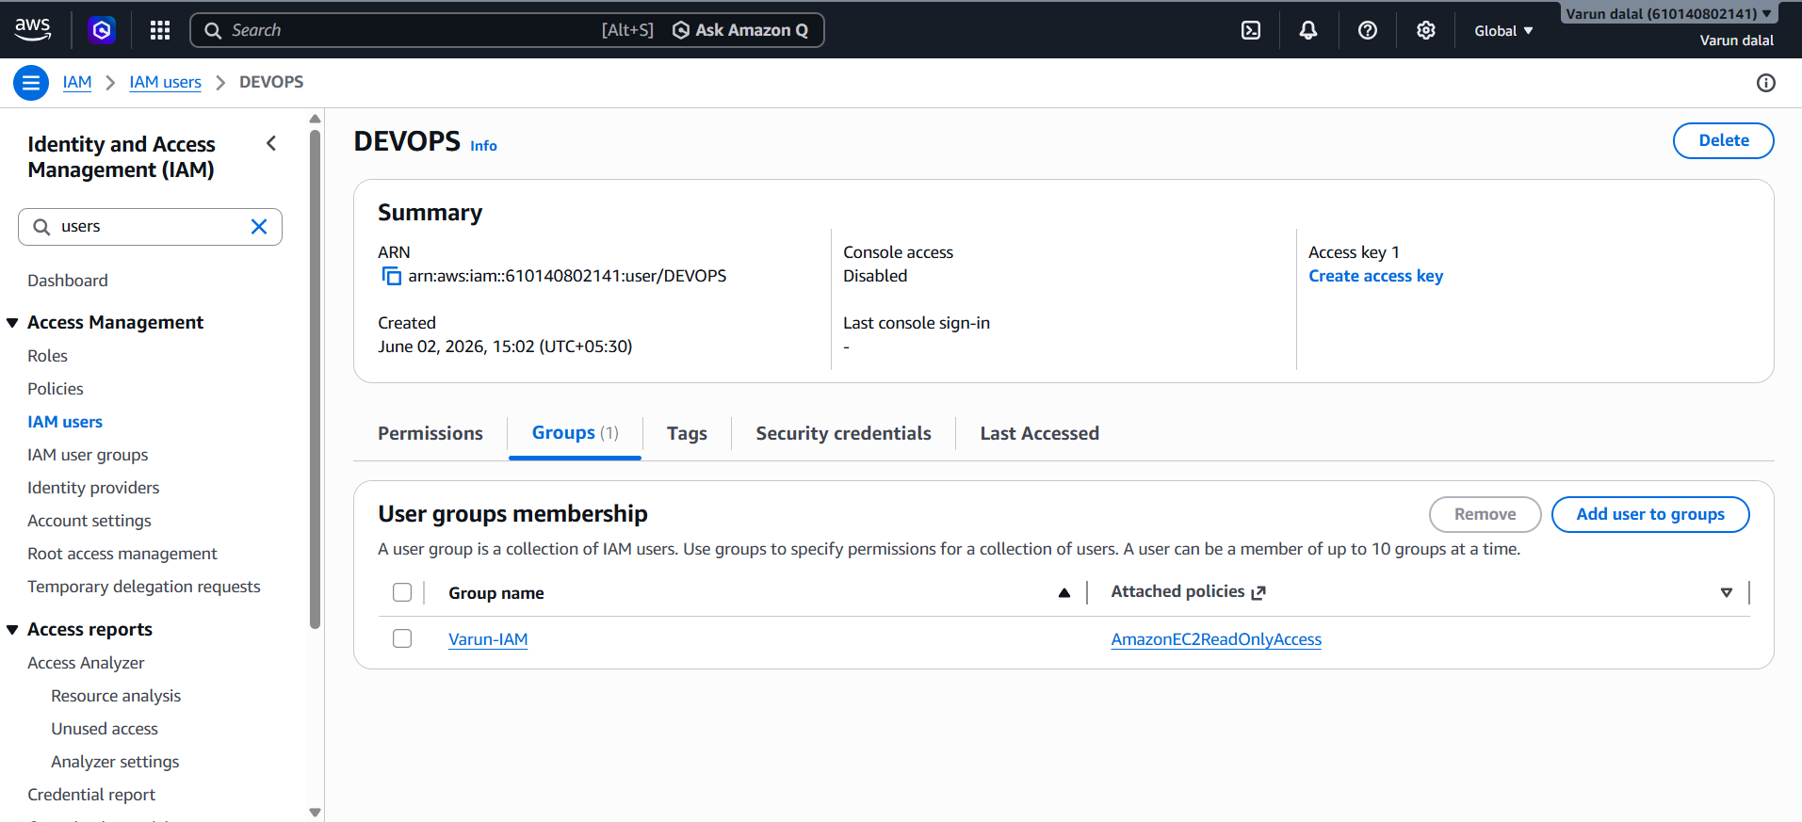
Validation
Step 12: Navigate to IAM → Users → Devops.
Step 13: Open the Groups tab.
Step 14: Verify that the user is a member of EC2ReadOnlyGroup.

4. Write a bash script to create an IAM user with VPC full access.
Step 1: Open Git Bash.
Step 2: Create a Bash script file.
Step 3: Add the following script:
#!/bin/bash
USER_NAME="VPCUser"
aws iam create-user --user-name $USER_NAME
aws iam attach-user-policy \
--user-name $USER_NAME \
--policy-arn arn:aws:iam::aws:policy/AmazonVPCFullAccess
Step 4: Save and exit the file.
Step 5: Provide execute permission.

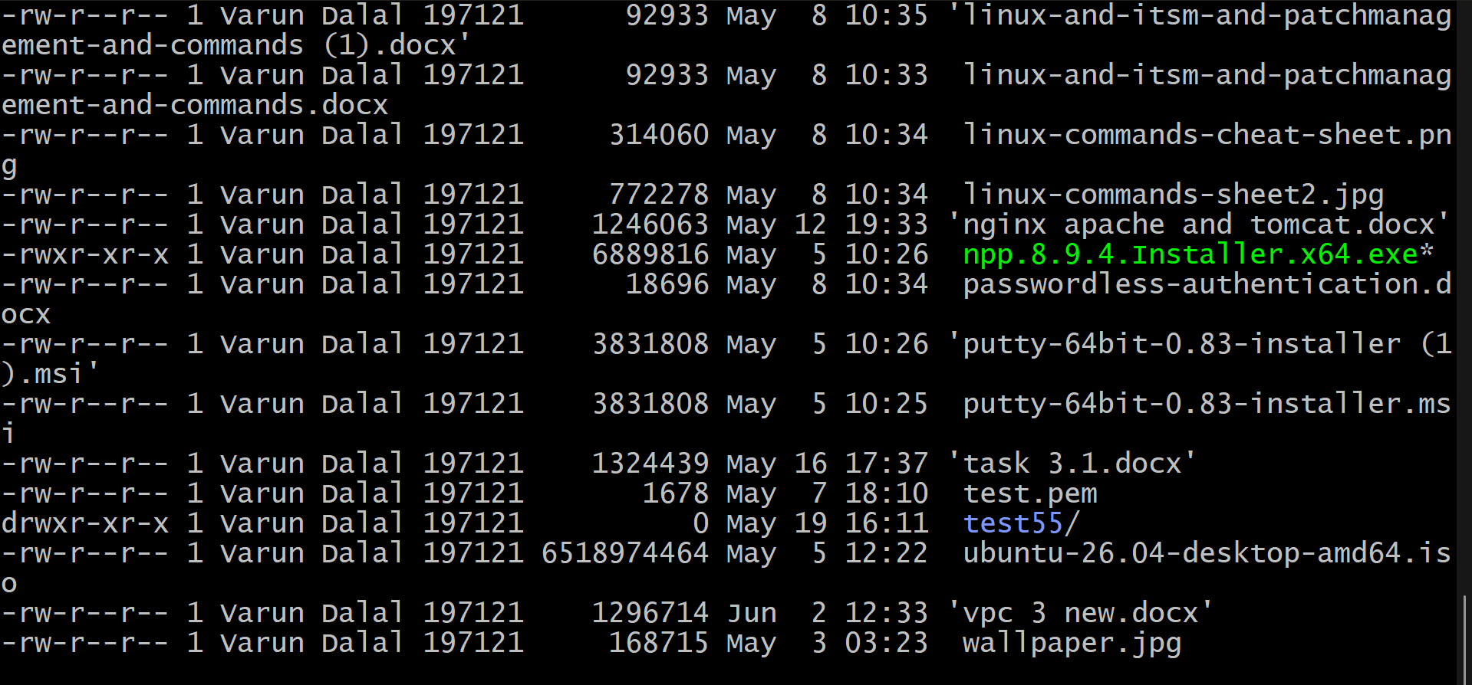
Validation
Validation 1: Verify the IAM User
aws iam get-user --user-name VPCUser
Output:
UserName: VPCUser

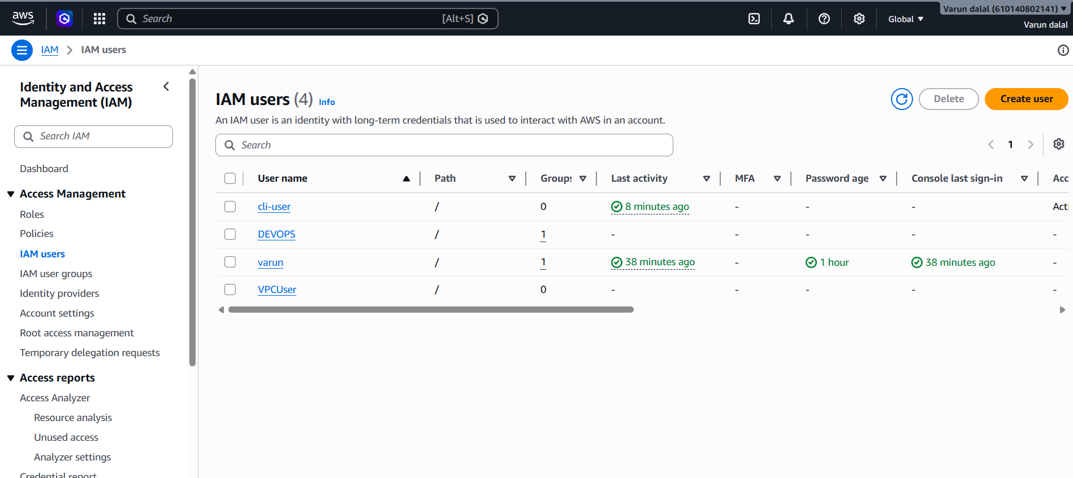

5.Create an IAM policy to allow EC2 access for a specific user in specific regions only
Step 1: Log in to AWS Management Console
Open the AWS Console and navigate to IAM.
Step 2: Create a New Policy
- Go to IAM → Policies
- Click Create Policy
- Select the JSON tab
Step 3: Paste the Following Policy
This example allows EC2 actions only in the us-east-1 region.
Step 4: Click Next
Review the policy.
Step 5: Enter Policy Details
- Policy Name: EC2-USEast1-Only
- Description: Allows EC2 access only in us-east-1 region
Step 6: Create the Policy
Click Create Policy.
Step 7: Attach the Policy to a User
- Navigate to IAM → Users
- Select the required user
- Open the Permissions tab
- Click Add Permissions
- Select Attach policies directly
- Choose EC2-USEast1-Only
- Click Add Permissions

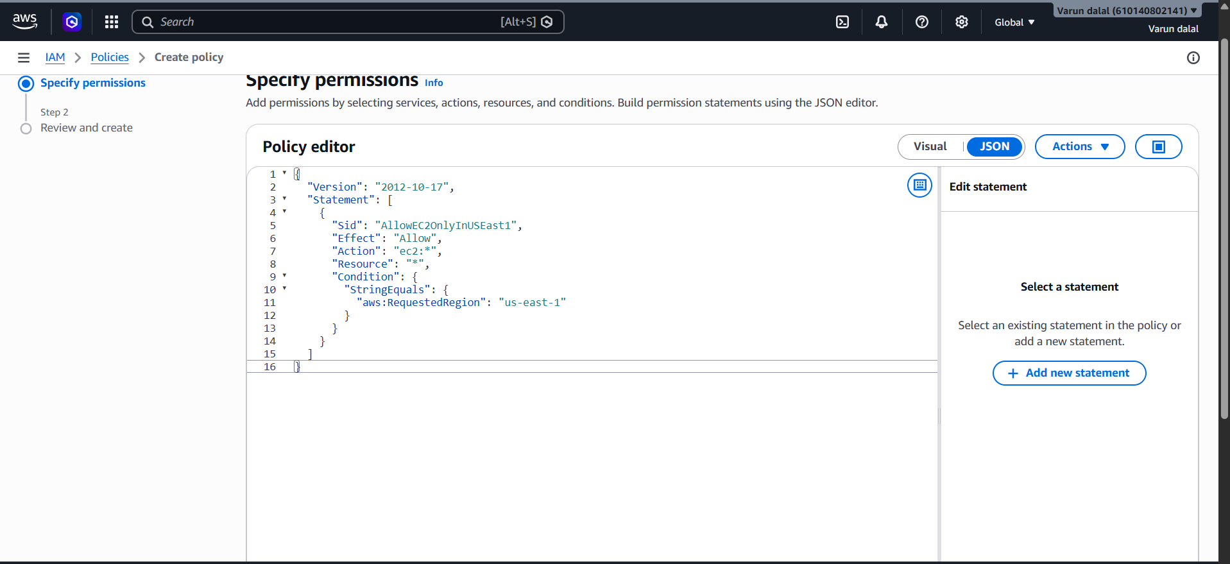
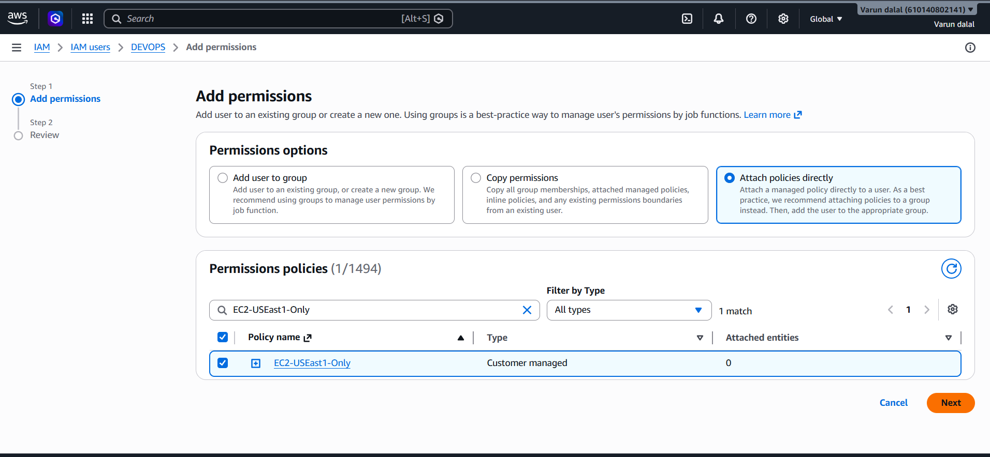
Validation
Validation 1: Check the Policy Is Attached
- Go to IAM → Users → User Name → Permissions
- Verify that EC2-USEast1-Only is listed.
Validation 2: Test in Allowed Region
- Switch AWS Region to us-east-1
- Open EC2 Console
- Create or manage EC2 resources
- Operation should succeed.
Validation 3: Test in Another Region
- Switch to us-west-2 (or any other region)
- Attempt to create an EC2 instance
- Access should be denied.

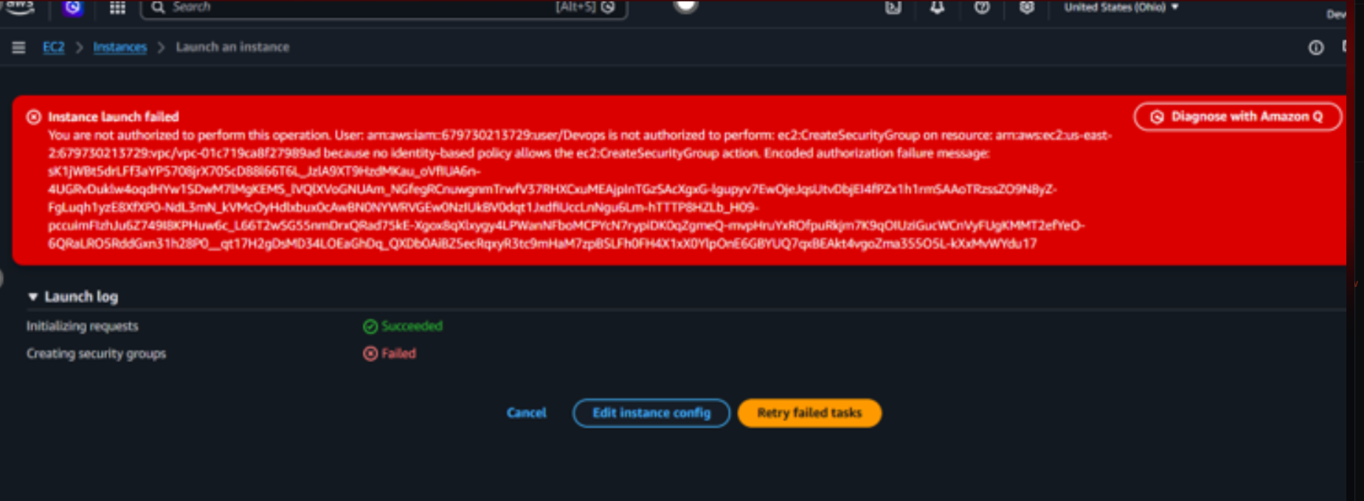
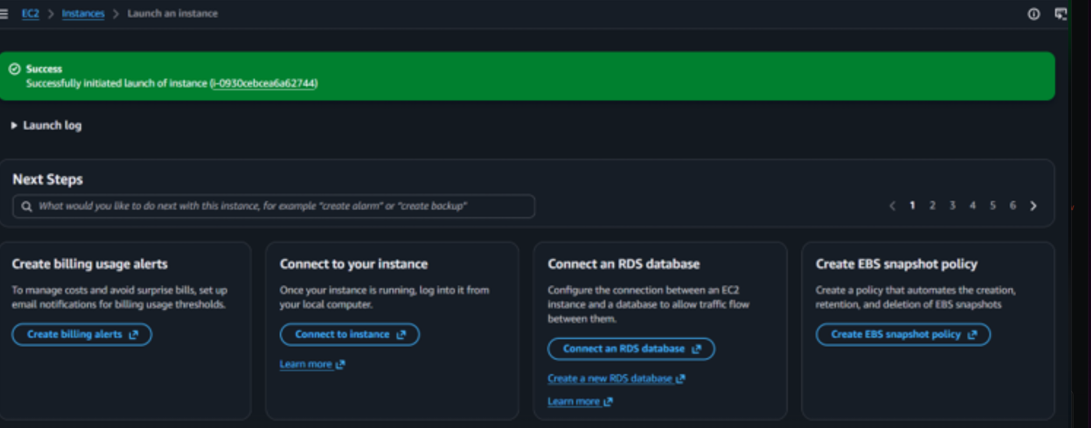

6. We have two accounts: Account A and Account B. Account A user should access an S3 bucket in Account B.
Step 1: Login to Account B
- Open AWS Console.
- Switch to Account B.
- Navigate to S3.
- Click Create Bucket.

Step 2: Create Test File in Bucket
- Open the bucket.
- Click Upload.
Step 3: Login to Account A
- Open AWS Console.
- Switch to Account A.
Step 4: Create IAM Policy in Account A
Step 5: Attach Policy to UserA
- Open UserA.
- Click:
Add Permissions
- Choose:
Attach policies directly
- Select:
AccountB-S3Access
- Click:
Add Permissions

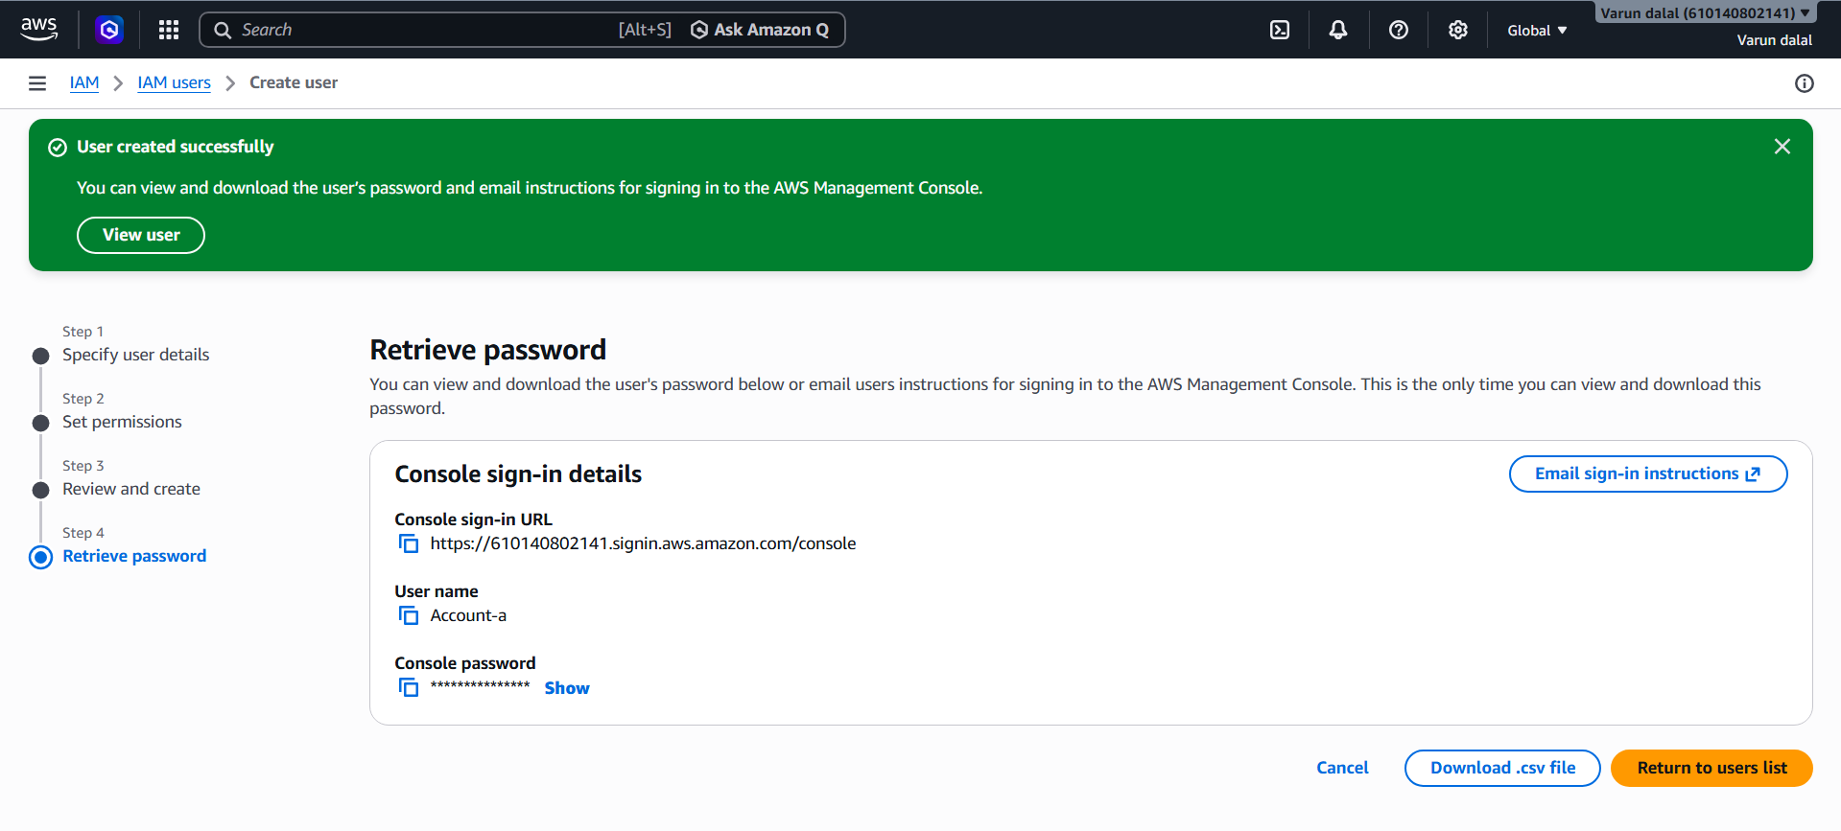
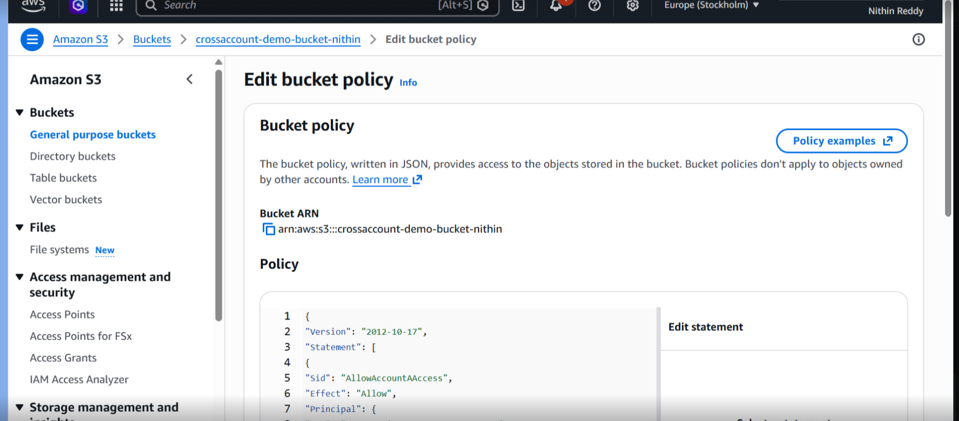

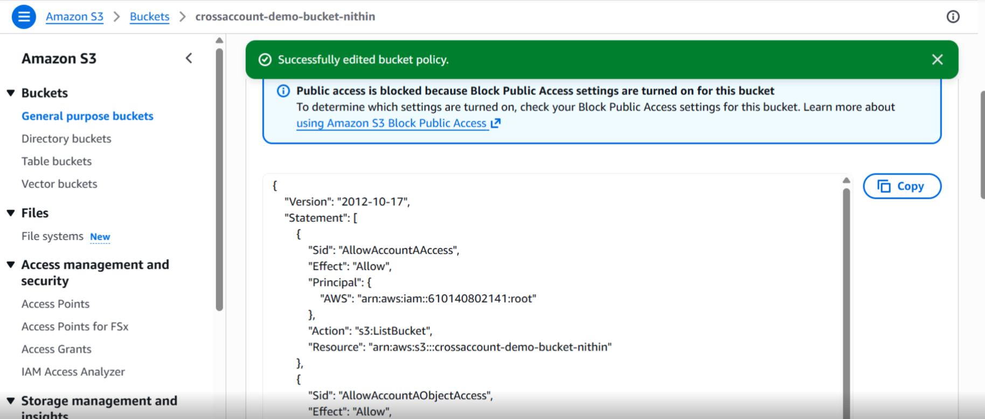
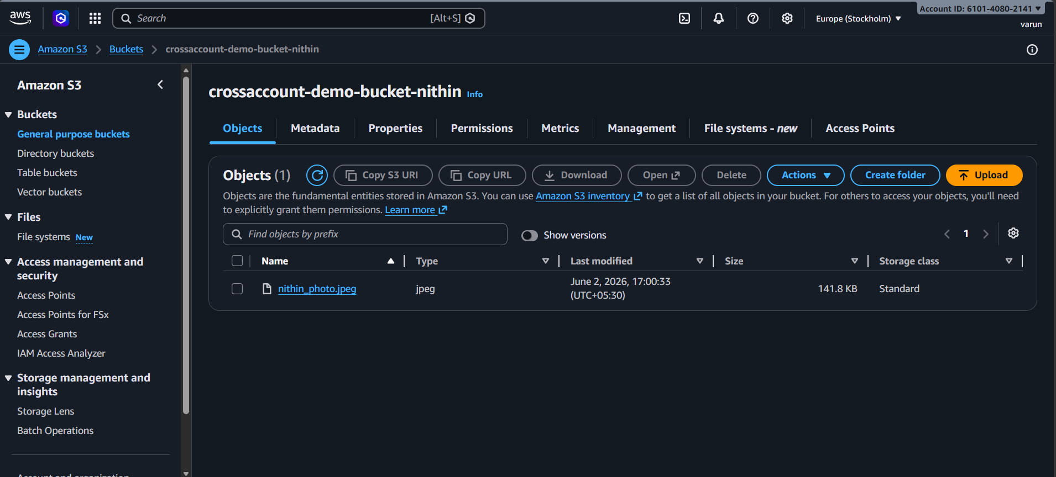
Final Validation Checklist
✅ Bucket created in Account B
✅ IAM User created in Account A
✅ IAM Policy attached to UserA
✅ Bucket Policy added in Account B
✅ AWS CLI configured with UserA credentials
✅ aws s3 ls works
✅ File upload works
✅ File download works

